**Part 1: Configure router ( Execute command on all routers )**

**Step 1: Configure secret on router**

R(config)# enable secret enpa55

**Step 2: Configure console password on router**

R(config)# line console 0

R(config-line)# password conpa55

R(config-line)# login

**Step 3: Configure SSH login on router**

R(config)# ip domain-name ccnasecurity.com

R(config)# username admin secret adminpa55

R(config)# line vty 0 4

R(config-line)# login local

R(config)# crypto key generate rsa

How many bits in the modulus [512]: 1024

**Step 4: Configure OSPF on routers**

**Execute command on router 1**

R1(config)#router ospf 1

R1(config-router)# network 192.168.1.0 0.0.0.255 area 0

R1(config-router)# network 10.1.1.0 0.0.0.3 area 0

**Execute command on router 2**

R2(config)#router ospf 1

R2(config-router)# network 10.1.1.0 0.0.0.3 area 0

R2(config-router)# network 10.2.2.0 0.0.0.3 area 0

**Execute command on router 3**

R3(config)#router ospf 1

R3(config-router)# network 10.2.2.0 0.0.0.3 area 0

R3(config-router)# network 192.168.3.0 0.0.0.255 area 0

**Part 2: Enable IOS IPS**

**Step 1: Enable the Security Technology package**

R1# show version

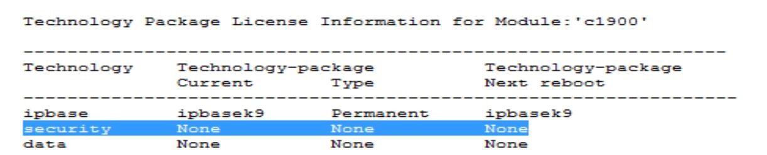

R1(config)# license boot module c1900 technology-package securityk9 ***(Type yes)***

R1# copy run start

R1# reload

R1# show version

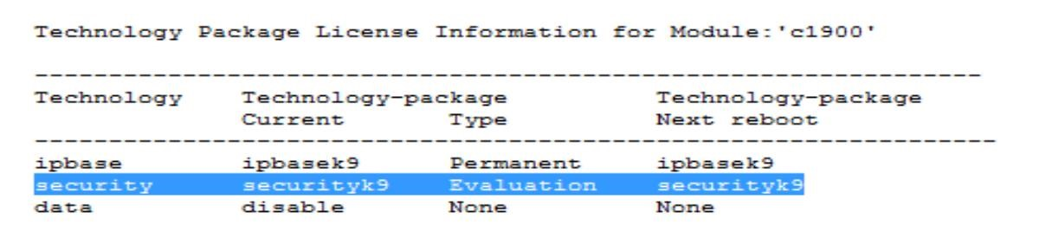

**Step 2: Verify network connectivity**

PCA> ping 192.168.3.2 (Successful)

PCC> ping 192.168.1.2 (Successful)

**Step 3: Create an IOS IPS configuration directory in flash.**

R1# mkdir ipsdir

Create directory filename [ipsdir]? <Enter>

**Step 4: Configure the IPS signature storage location**.

R1(config)# ip ips config location flash:ipsdir

**Step 5: Create an IPS rule**

R1(config)# ip ips name iosips

**Step 6: Enable logging.**

R1(config)# ip ips notify log

R1# clock set hr:min:sec date month year

R1(config)# service timestamps log datetime msec

R1(config)# logging host 192.168.1.50

**Step 7: Configure IOS IPS to use the signature categories**.

R1(config)# ip ips signature-category

R1(config-ips-category)# category all

R1(config-ips-category-action)# retired true

R1(config-ips-category-action)# exit

R1(config-ips-category)# category ios_ips basic

R1(config-ips-category-action)# retired false

R1(config-ips-category-action)# exit

R1(config-ips-cateogry)# exit

Do you want to accept these changes? [confirm] <Enter>

**Step 8: Apply the IPS rule to an interface.**

R1(config)# int gig0/0

R1(config-if)# ip ips iosips out

**Step 9: Use show commands to verify IPS.**

R1# show ip ips all

(Output)

**Step 10: View the syslog messages**.

Click the Syslog server->Services tab-> SYSLOG

(Output)

**Part 3: Modify the Signature**

**Step 1: Change the event-action of a signature.**

R1(config)# ip ips signature-definition

R1(config-sigdef)# signature 2004 0

R1(config-sigdef-sig)# status

R1(config-sigdef-sig-status)# retired false

R1(config-sigdef-sig-status)# enabled true

R1(config-sigdef-sig-status)# exit

R1(config-sigdef-sig)# engine R1(config-sigdef-sig-engine)# event-action produce-alert

R1(config-sigdef-sig-engine)# event-action deny-packet-inline

R1(config-sigdef-sig-engine)# exit

R1(config-sigdef-sig)# exit

R1(config-sigdef)# exit

Do you want to accept these changes? [confirm] <Enter>

**Step 2: Use show commands to verify IPS.**

R1# show ip ips all

(Output)

**Step 3: Verify that IPS is working properly.**

PCC> ping 192.168.1.2(Unsuccessful – Request timed out)

PCA> ping 192.168.3.2(Successful)

**Step 4: View the syslog messages.**

Click the Syslog server->Services tab-> SYSLOG